Ches Deul 1158163
Zuyd university
MICT1- Exercise week 2

Contents
What you found 1
Where you found it 1
How you found it. 2
Answers to any possible questions 2

Exercise for week 2:

- Investigate the provided media files 'file1.png' and 'file2.mng'.
- 'file1.png' contains a clue as to how to handle (part of the challenge of) 'file2.mng', so work in that order.
- Make a small report describing:
- What you found
- Where you found it (file, locations)
- How you found it. What tools? Include source, screenshots, howto's, etc.
- Answers to any possible questions that may have been asked

What you found
Op het einde van de file genaamd “file1.png” de volgende hint gevonden; “MICT1Hint Het bericht in de andere file moet via ROT13 worden gedecodeerd. Succes!”.
De vraag is dus encoded met behulp van ROT13.

Where you found it

file1.png
offset 001c15f5
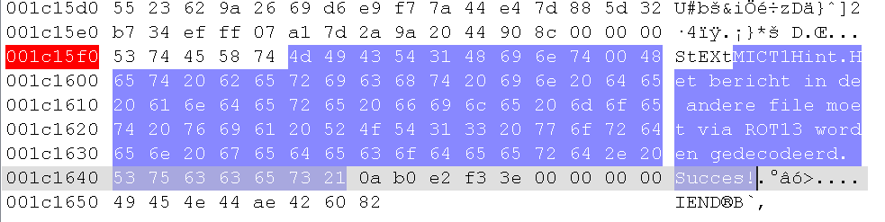

How you found it.

Answers to any possible questions

